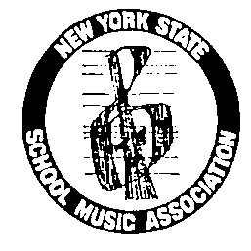
NYSSMA
A State Unit of NAfME, National Association for Music Education ____________________________________________________________________________________

Sample SLO’s created by the NYSSMA Curriculum Committee

July 2012

The NYSSMA Committee has generated two sample Student Learning Objectives (SLO) to help guide you through the process of creating your own.

These examples were created using the state SLO template, found at EngageNY http://engageny.org/resource/new-york-state-student-learning-objective-template/
We have also attached the template below for your convenience.

Additional helpful sites to explore:
SLO Roadmap: http://engageny.org/wp-content/uploads/2012/03/slo-roadmap.pdf

NYSED Guidance document – p. 23, scoring model; and p.32, example model for band:
http://engageny.org/wp-content/uploads/2012/03/slo-guidance.pdf

Related documents:
SLO High School Band (chorus/orchestra), grade 9 - Sightreading
SLO Composition, grade 5
SLO template
OCMBOCES SLO: Music 5 (performance)
OCMBOCES SLO: Music 5 (sightreading)
OCMBOCES SLO: Instrumental Music

___________________________________________________________________________________________________________
Frederic A. Weingarten, Curriculum Chairperson, 31 Hunters Run, Pittsford, NY 14534-3457
(P) (585) 248-2439 * Musarts@aol.com

NYSSMA is a registered trademark of the New York State School Music Association

