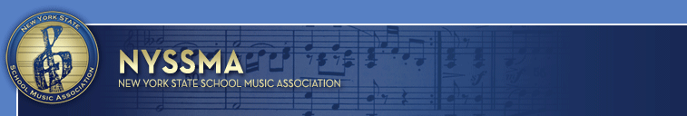
CONTACT: Dr. John J. Gallagher
631-294-2279 (cell)
PR@nyssma.org

@OfficialNYSSMA

Music Educators from Across New York State
Advocate in Albany During
45th Annual Joseph R. Sugar NYSSMA Day in Albany

Annual Event Kicks Off Music In Our Schools Month

February 16, 2018 - Westbury, NY – New York State legislators will be visited by music educators and administrators – and treated to concerts by All-State musicians in Albany on Monday, March 5, 2018 during NYSSMA’s 45th annual Joseph R. Sugar NYSSMA Day in Albany.

As is tradition, the students in the All-State Instrumental and Vocal Jazz Ensembles will be the featured performers at an 11:30 a.m. concert in the South Concourse of the Empire State Plaza.

"NYSSMA looks forward to the ongoing efforts with our state legislators to advocate that all students, pre-kindergarten through twelfth grade, deserve a well-rounded education which includes high-quality, comprehensive and sequential music education" said Michael Salzman, NYSSMA President.

Music In Our Schools Month originated in New York State in 1973 as a single day concert at New York City’s Lincoln Center. Created by the New York State School Music Association (NYSSMA), it was one of the first public events held to support music education programs throughout New York State.

It was named after the late Joseph R. Sugar, who served as NYSSMA’s president from 1980 to 1981, and as NYSSMA’s Government Relations Chairperson for many years after. He also served as Eastern Division President of The National Association for Music Education (NAfME), based in Reston, VA.

In 1985, NAfME adopted the idea and now celebrates Music in Our Schools Month across America each March.

NYSSMA, the New York State School Music Association, is in its 86th year of advocacy for music education on behalf of the 1.8 million students across the state, and is proud to be one of the largest state affiliates of The National Association for Music Education (NAfME).

The mission of the New York State School Music Association is to advocate for and improve music education across New York State by promoting and producing appropriate activities and programs for its membership and students in member school music programs.

# # #

