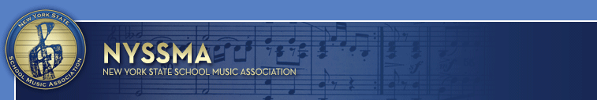
CONTACT: Dr. John J. Gallagher
631-294-2279 (cell)
PR@nyssma.org
Follow us on Twitter @OfficialNYSSMA
Like us on Facebook Official NYSSMA
Statistics and History of
NYSSMA’S Music In Our Schools Month Event

With a stroke of his pen, Governor Andrew Cuomo has claimed March, 2018 Music In Our Schools Month in New York State. The 45th annual event was originally formed in Nassau County in 1973 and is sponsored by the New York State School Music Association (NYSSMA). It was the first coalition that advocated support for music education programs throughout New York State.

The Legislature of the State of New York has a history of supporting NYSSMA and Music In Our Schools Month. In 1980, it financed a weekend of music by the all-state band, orchestra and chorus in the Convention Center in Albany. This event expanded into one known as The Capital Experience, a program that includes daily concerts by student bands, choruses and orchestras throughout the Plaza from all over New York State. This event gives students who might not otherwise have the opportunity to visit the Capital to perform for a large and audience.

To obtain national exposure for the event, NYSSMA had passed the event on to The National Association for Music Education (NAfME) in 1985. Since then, it has become a time of year when music education becomes the focus of schools across the nation. Schools and communities throughout the country and overseas celebrate with concerts and other activities based on the year's theme. Classrooms, concert halls, civic buildings, clubs, parks, libraries, and shopping malls are just some of the arenas in which the public can observe the processes and results of music education.

In 2018, NYSSMA celebrates its 86th year as one of the largest state affiliates of NAfME. NYSSMA’s mission is to advocate for and improve music education across New York State by promoting and producing appropriate activities and programs for its membership and students in member school music programs.

NYSSMA holds hundreds of solo and ensemble festivals state-wide each year. Over one hundred thousand (100,000) students are adjudicated at these festivals. Approximately two thousand (2,000) music educators converge each December for the annual All State/Winter Conference for professional development opportunities, seminars, clinics and performances by its nine all state instrumental and vocal ensembles. Approximately nine hundred (900) students perform in these ensembles.
NYSSMA is one of the largest most successful state units of NAfME in the country:
- Approximately 4,000 members proudly belong to NYSSMA.
- 100,000 students participate annually in spring adjudication festivals held around New York State
- The NYSSMA Winter Conference attracts four thousand (4,000) students, teachers, clinicians and others, and offers approximately two hundred (200) workshops and showcases.
- Approximately sixty-seven hundred (6,700) students audition for the eight All-State performing groups. However, just under 900 are selected to participate.
- The New York State Summer Music Conference is devoted to professional development for music teachers and is held in Albany in August.
- NYSSMA’s publication, The School Music News, is mailed to every member eight (8) times per year and keeps everyone fully informed.
- The NYSSMA Manual is the definitive resource for setting standards and expectations for each instrument and voice part at every level.
- Approximately 5,500 followers on Twitter and Facebook.

