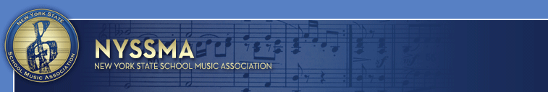
FOR IMMEDIATE RELEASE CONTACT: Dr. John J. Gallagher
631-294-2279 (cell)
PR@nyssma.org

@OfficialNYSSMA

Music Educator Assumes Leadership Role

Will lead NYSSMA’s efforts to provide professional development opportunities to music educators
At annual Summer Conference in Albany

January 6, 2017, Westbury, NY – The New York State School Music Association is proud to announce the election of Robin DeSantis, retired music educator from the Henderson and Windsor Central School Districts, to the position of Third Vice President. In this role, she will oversee the effective management of the annual New York State Summer Music Conference held in Albany. The Conference is co-sponsored by six (6) professional music educators associations throughout New York State and J.W. Pepper & Son Music Corporation.

“We are proud to have someone of Robin’s background and expertise as our liaison to our annual Summer Music Conference,” said NYSSMA President, Michael Brownell. “Well-known at this conference as a teacher, facilitator, conductor and performer, Robin’s experience will prove invaluable as we continue to provide quality professional development for our members preparing to return to school in September.”

Mrs. DeSantis received her undergraduate and graduate degrees from the Crane School of Music at SUNY Potsdam. From 1976-1980, she taught Vocal and Instrumental Music to students in grades kindergarten through twelve in the Henderson CSD. From 1980 to her retirement in 2010, Mrs. DeSantis taught band to students in elementary through high school at the Windsor CSD.

An active musician and conductor, Mrs. DeSantis has conducted several all-county and area all state bands, and has conducted throughout Europe. In addition to holding office with NYSSMA and NYSBDA, she has held leadership positions with the Broome County Music Educators Association, the Council of Music Educator Associations, the National Band Association, and currently performs with the Southern Tier Concert Band and the Vestal Community Band.

Mrs. DeSantis has been the recipient of Distinguished Service Awards from the Broome County Music Educators Association and the New York State Band Directors Association.

NYSSMA, the New York State School Music Association, is the largest state affiliate of the National Association for Music Education. NYSSMA’s mission is to advance music education across New York State for its membership and students in member school programs.

# # #

