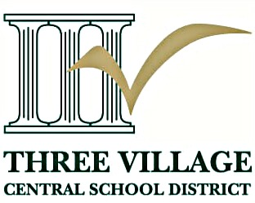

ANTICIPATED VACANCY
2024-2025 SCHOOL YEAR

Orchestra Teacher (Substitute)

December 9, 2024 – February 28, 2025

The Three Village Central School District is seeking a qualified individual to serve in a short-term assignment for the Ward Melville High School orchestra.

Key responsibilities would include:

- Preparing the Symphony Orchestra and Chamber Orchestra for their Winter Concerts and conducting these groups in their concerts.
- Leading daily rehearsals for these groups during the school day.
- Providing small group lesson instruction and running sectionals for students in these groups.
- Involvement with smaller-scale school music department events/performances where applicable.

The ideal candidate would have experience working with a high school orchestra; demonstrate confidence instructing and guiding high-level performing groups, and exhibit strong communication and leadership skills. The candidate must be available for the full assignment.

Must be NYS Music Certified.

Salary is in accordance with the substitute teachers’ contract.

Candidates may be subject to fingerprinting and a background check.

Anyone interested in applying for the above-mentioned position should complete an application on RecruitFront and/or visit the Human Resources page of the Three Village website no later than October 27, 2024.

We are an equal-opportunity employer.

