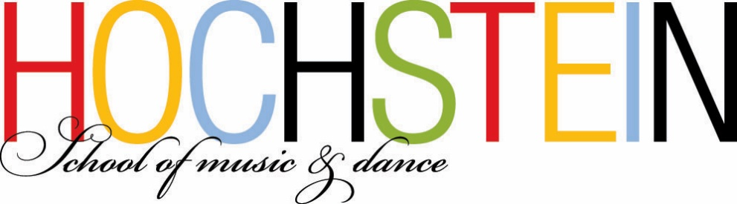

Seeking Early Childhood Music Teacher
For Music FUNdamentals Classes, Saturday mornings
Hochstein School of Music & Dance
50 N Plymouth Ave., Rochester, NY 14614

The Hochstein School seeks a qualified teacher of early childhood music for three Music FUNdamentals classes on Saturday mornings (9am – noon) for the following:
Music for Little Ones (ages 6-18 months, with parent/caregiver)
Music for Tiny Tots (ages 18-30 months, with parent/caregiver)
Music for Tots (ages 30 months – 3 years, with parent/caregiver)

All classes focus on age-appropriate movement, singing, chanting, and instrument play, using traditional and multi-cultural songs, nursery rhymes, and activities designed to foster a child’s natural curiosity for music, developing the building blocks of musical language and a foundation for and love of music.

Our Music FUNdamentals classrooms include a piano, playback equipment, and a variety of age-appropriate instruments and materials.

We seek an enthusiastic teacher who can provide a welcoming, nurturing environment for children and their parents/caregivers and who can offer a variety of musical activities based on the research and programs of various experts in the field of early childhood music education.

Position available September 2017. Hochstein classes run September – June (36 weeks).

Job Requirements:
Bachelor’s degree in Music Education, with experience teaching Early Childhood Music.

Qualified candidates should submit letter of interest, résumé, and contact information for 3 references to: both Alice Pratt, Chair, Music FUNdamentals Department, and Margaret Quackenbush, President & Executive Director via email to: alice.pratt@hochstein.org and director@hochstein.org

50 N. Plymouth Ave., Rochester NY 14614 www.hochstein.org tel. (585)454-4596 fax (585)454-4393

